Lab #7
Adam Jaso
10/25/11
Lab #7: Numerical Differentiation

Objective
The objective of this lab is to determine the derivative of x * e ^ x at a given point using the forward, central, and backward differencing methods.

Procedure
All of the methods of numerical differentiation explored in this lab essentially use the definition of the derivative on a very small interval.
- Theory
  - Forward and Backward differencing are both very similar. Forward differencing considers one point, x, and uses a small positive interval, Δx, in the definition of the derivative to approximate the derivative at the point, x: df/dx ≈ (f(x+Δx)-f(x))/Δx.
  - Backward differencing simply uses a negative interval, Δx, in the definition of the derivative: df/dx ≈ (f(x-Δx)-f(x))/Δx.
  - Central Differencing: df/dx ≈ (f(x+Δx)-f(x-Δx))/(2*Δx). Central differencing uses small half-sized intervals equally spaced on either side of the point, x, in the definition of the derivative.
- Coding
  - Calculate the approximate derivatives for each of the three methods mentioned above.
  - Loop through the derivatives displaying the size of interval used along with the three respective approximations. Here I included a variant of the Central differencing method for comparison with the conventional method: df/dx ≈ (f(x+Δx/2)-f(x-Δx/2))/Δx.
  - Plot the differences of the three approximations from the exact derivative.

Observations
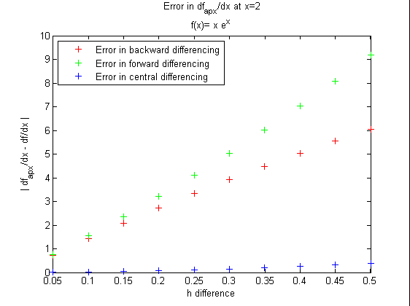
The above plot shows the error in approximation methods for successively smaller intervals from 0.5 to 0.05. 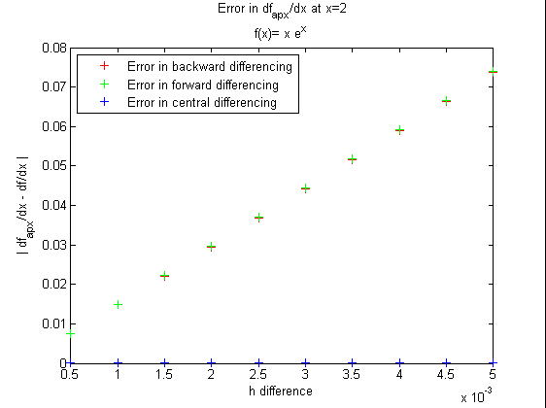
The above plot shows the error in approximation methods for very small intervals on the order of 10^-3.

Below I’ve included a couple of logarithmically scaled plots for these small scale intervals.

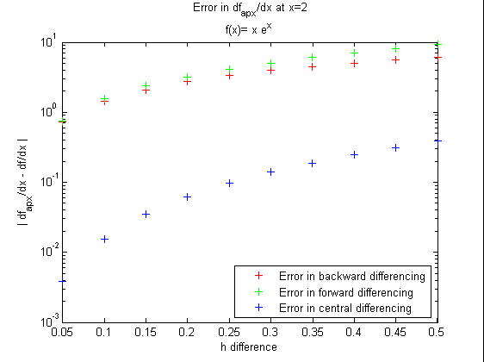

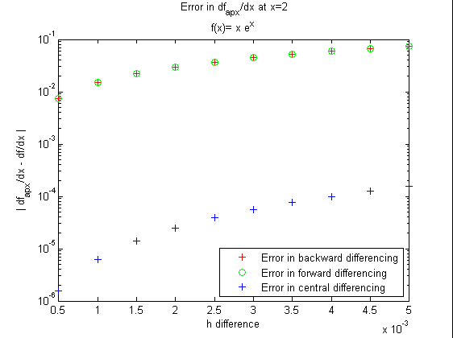

Notice that that the backward differencing method is more accurate than the forward differencing method in the first of the four plots given above. Observe in the logarithmic plot on the order of 10^-3 that the central differencing method is nearly four orders of magnitude more accurate than the forward and backward.

Code / Results

***** DERIVATIVE.M CODE *****

function []=derivative(x)
%derivative.m
%This function calculates the derivative of x*e^x using backward, forward
%and central differencing.

%define the h differences
d=0.005:-0.0005:0.0005;

%calculate the derivatives for the three methods
db=dback(x,d);
df=dforw(x,d);
dc=dcent(x,d);

%display the differences with their corresponding derivative approximations
for i=1:length(d)
fprintf('h = %f backward: df/dx = %f forward: df/dx = %f central: df/dx = %f\n',d(i),db(i),df(i),dc(i));
end

%calculate the exact value of the derivative
da=dfdx(x);

%calculate the differences of the respective approximations to the exact
%derivative
diffback=abs(db-da);
diffforw=abs(df-da);
diffcent=abs(dc-da);

%plot the three differences of approximations
plot(d,diffback,'r+');
ylabel('| df_a_p_x/dx - df/dx |');
xlabel('h difference');
hold on;
plot(d,diffforw,'g+');
plot(d,diffcent,'b+');
title({strcat(' Error in df_a_p_x/dx at x= ',num2str(x)),'f(x)= x e^x'});
set(legend('Error in backward differencing','Error in forward differencing','Error in central differencing'),'Location','SouthEast');

set(gca,'YScale','log');

end

%backward difference approximation
function db=dback(x,d)
db=(f(x)-f(x-d))./d;
end
function d2b=d2back(x,d)
d2b=(f(x-2*d)-2*f(x-d)+f(x))./d.^2;
end

%forward difference approximation
function df=dforw(x,d)
df=(f(x+d)-f(x))./d;
end
function d2f=d2forw(x,d)
d2f=(f(x+2*d)-2*f(x+d)+f(x))./d.^2;
end

%central difference approximation #1
function dc=dcent(x,d)
dc=(f(x+d)-f(x-d))./(2*d);
end
function d2c=d2cent(x,d)
d2c=(f(x+d)-2*f(x)+f(x-d))./d.^2;
end

%central difference approximation #2
function dc=dcent2(x,d)
dx=d/2;
dc=(f(x+dx)-f(x-dx))./d;
end

%function definition of x*e^x
function f=f(x)
f=x.*exp(x);
end

%derivative of the function x*e^x
function dfdx=dfdx(x)
dfdx=(x+1).*exp(x);
end

***** NEWTON.M RESULTS *****

>> derivative(2)
h = 0.005000 backward: df/dx = 22.093431 forward: df/dx = 22.241213 central: df/dx = 22.167207
h = 0.004500 backward: df/dx = 22.100791 forward: df/dx = 22.233795 central: df/dx = 22.167199
h = 0.004000 backward: df/dx = 22.108154 forward: df/dx = 22.226379 central: df/dx = 22.167193
h = 0.003500 backward: df/dx = 22.115520 forward: df/dx = 22.218967 central: df/dx = 22.167187
h = 0.003000 backward: df/dx = 22.122889 forward: df/dx = 22.211558 central: df/dx = 22.167182
h = 0.002500 backward: df/dx = 22.130261 forward: df/dx = 22.204152 central: df/dx = 22.167178
h = 0.002000 backward: df/dx = 22.137637 forward: df/dx = 22.196749 central: df/dx = 22.167174
h = 0.001500 backward: df/dx = 22.145015 forward: df/dx = 22.189349 central: df/dx = 22.167172
h = 0.001000 backward: df/dx = 22.152396 forward: df/dx = 22.181953 central: df/dx = 22.167170
h = 0.000500 backward: df/dx = 22.159781 forward: df/dx = 22.174559 central: df/dx = 22.167169

